The Great Metropolitan Art Hunt

Can you find the following Artists?????

___Renoir
___Matisse
___Pissarro
___Cezanne
___Botticelli
___Lichtenstein
___Pollock
___Dali
___Picasso
___Van Gogh
___Rousseau
___Gauguin
___Monet
___Manet
___Degas
___Bonheur
___Rodin
___Rubens
___El Greco
___Velazquez
___Vermeer
___Rembrandt
___Raphael

Awesome Artist Vocabulary

Wordly wise stand aside!!! How about these mega words:

___Realism
___Impressionism
___Surrealism
___Cubism
___Baroque Art
___Post-Impressionism
___Pop Art
___Modern Art
___Abstract-Impressionist

Symbols in Religious Art. Did you find:

___Lily Flower
___Halo
___Book
___Globe
___Griffin
___Lion
___Dove
___Sheep
___Lute

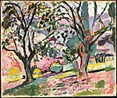

Olive Trees at Collioure
Henri Matisse (French, Le Cateau-Cambrésis 1869–1954 Nice)
Date: summer 1905 (?)
Gallery 962

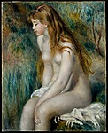

Young Girl Bathing
Auguste Renoir (French, Limoges 1841–1919 Cagnes-sur-Mer)
Date: 1892
Gallery 961

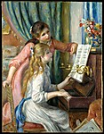

Two Young Girls at the Piano
Auguste Renoir (French, Limoges 1841–1919 Cagnes-sur-Mer)
Date: 1892
Gallery 961

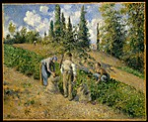

The Harvest, Pontoise (La Récolte, Pontoise)
Camille Pissarro (French, Charlotte Amalie, Saint Thomas 1830–1903 Paris)
Date: 1881
Gallery 961

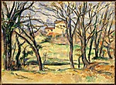

Trees and Houses Near the Jas de Bouffan
Paul Cézanne (French, Aix-en-Provence 1839–1906 Aix-en-Provence)
Date: 1885–86
Gallery 961

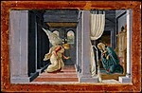

The Annunciation
Botticelli (Alessandro di Mariano Filipepi) (Italian, Florence 1444/45–1510 Florence)
Date: ca. 1485
Gallery 959

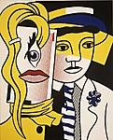

Stepping Out
Roy Lichtenstein (American, New York City 1923–1997 New York City)
Date: 1978
Gallery 924

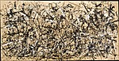

Autumn Rhythm (Number 30)
Jackson Pollock (American, Cody, Wyoming 1912–1956 East Hampton, New York)
Date: 1950
Gallery 921

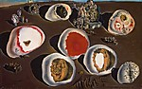

The Accommodations of Desire
Salvador Dalí (Spanish, Figueres 1904–1989 Figueres)
Date: 1929
Gallery 907

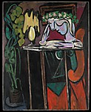

Reading at a Table
Pablo Picasso (Spanish, Malaga 1881–1973 Mougins, France)
Date: 1934
Gallery 902

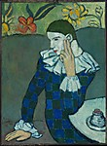

Seated Harlequin
Pablo Picasso (Spanish, Malaga 1881–1973 Mougins, France)
Date: 1901
Gallery 830

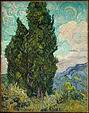

Cypresses
Vincent van Gogh (Dutch, Zundert 1853–1890 Auvers-sur-Oise)
Date: 1889, Gallery 826

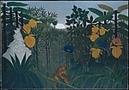

The Repast of the Lion
Henri Rousseau (le Douanier) (French, Laval 1844–1910 Paris)
Date: ca. 1907
Gallery 826

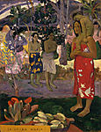

Ia Orana Maria (Hail Mary)
Paul Gauguin (French, Paris 1848–1903 Atuona, Hiva Oa, Marquesas Islands)
Date: 1891
Gallery 826

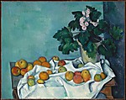

Still Life with Apples and a Pot of Primroses
Paul Cézanne (French, Aix-en-Provence 1839–1906 Aix-en-Provence)
Date: ca. 1890
Gallery 825

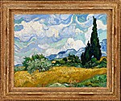

Wheat Field with Cypresses
Vincent van Gogh (Dutch, Zundert 1853–1890 Auvers-sur-Oise)
Date: 1889
Gallery 823

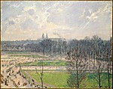

The Garden of the Tuileries on a Winter Afternoon
Camille Pissarro (French, Charlotte Amalie, Saint Thomas 1830–1903 Paris)
Date: 1899
Gallery 820

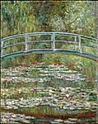

Bridge over a Pond of Water Lilies
Claude Monet (French, Paris 1840–1926 Giverny)
Date: 1899
Gallery 819
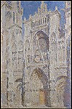

Rouen Cathedral: The Portal (Sunlight)
Claude Monet (French, Paris 1840–1926 Giverny)
Date: 1894
Gallery 819

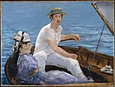

Boating
Édouard Manet (French, Paris 1832–1883 Paris)
Date: 1874
Gallery 818

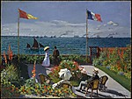

Garden at Sainte-Adresse
Claude Monet (French, Paris 1840–1926 Giverny)
Date: 1867
Gallery 818

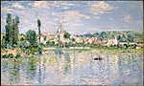

Vétheuil in Summer
Claude Monet (French, Paris 1840–1926 Giverny)
Date: 1880
Gallery 818

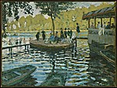

La Grenouillère
Claude Monet (French, Paris 1840–1926 Giverny)
Date: 1869
Gallery 818

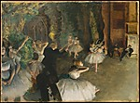

The Rehearsal of the Ballet Onstage
Edgar Degas (French, Paris 1834–1917 Paris)
Date: probably 1874
Gallery 816

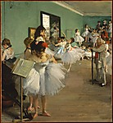

The Dance Class
Edgar Degas (French, Paris 1834–1917 Paris)
Date: 1874
Gallery 815

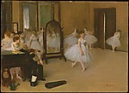

The Dancing Class
Edgar Degas (French, Paris 1834–1917 Paris)
Date: ca. 1870
Gallery 815

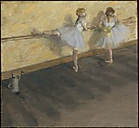

Dancers Practicing at the Barre
Edgar Degas (French, Paris 1834–1917 Paris)
Date: 1877
Gallery 815

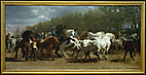

The Horse Fair
Rosa Bonheur (French, Bordeaux 1822–1899 Thomery)
Date: 1853–55
Gallery 812

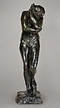

Eve
Auguste Rodin (French, Paris 1840–1917 Meudon)
Date: modeled in 1881, this bronze cast 1910
Gallery 800

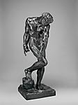

Adam
Auguste Rodin (French, Paris 1840–1917 Meudon)
Date: modeled in 1880 or 1881, this bronze cast 1910
Gallery 800
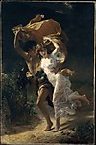

The Storm
Pierre-Auguste Cot (French, Bédarieux 1837–1883 Paris)
Date: 1880
Gallery 800

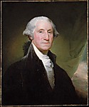

George Washington
Gilbert Stuart (American, North Kingston, Rhode Island 1755–1828 Boston, Massachusetts)
Date: begun 1795
Gallery 774

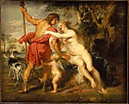

Venus and Adonis
Peter Paul Rubens (Flemish, Siegen 1577–1640 Antwerp) Date: mid- or late 1630s
Gallery 629

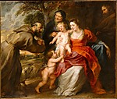

The Holy Family with Saints Francis and Anne and the Infant Saint John the Baptist

Peter Paul Rubens (Flemish, Siegen 1577–1640 Antwerp) Date: probably early 1630s

Gallery 629

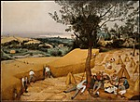

The Harvesters
Pieter Bruegel the Elder (Netherlandish, Breda (?) ca. 1525–1569 Brussels)
Date: 1565
Gallery 627

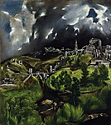

View of Toledo
El Greco (Domenikos Theotokopoulos) (Greek, Candia 1540/41–1614 Toledo)
Gallery 619

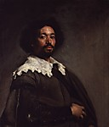

Juan de Pareja (born about 1610, died 1670)
Velázquez (Diego Rodríguez de Silva y Velázquez) (Spanish, Seville 1599–1660 Madrid)
Date: 1650
Gallery 618

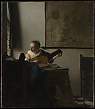

Woman with a Lute
Johannes Vermeer (Dutch, Delft 1632–1675 Delft)
Date: ca. 1662–63, Gallery 616

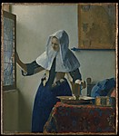

Young Woman with a Water Pitcher
Johannes Vermeer (Dutch, Delft 1632–1675 Delft)
Date: ca. 1662
Gallery 616

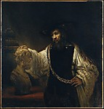

Aristotle with a Bust of Homer
Rembrandt (Rembrandt van Rijn) (Dutch, Leiden 1606–1669 Amsterdam)
Date: 1653
Gallery 614

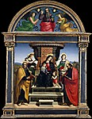

Madonna and Child Enthroned with Saints
Raphael (Raffaello Sanzio or Santi) (Italian, Urbino 1483–1520 Rome)
Date: ca. 1504
Gallery 608

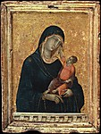

Madonna and Child
Duccio di Buoninsegna (Italian, active by 1278–died 1318 Siena)
Date: ca. 1300
Gallery 602

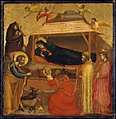

The Epiphany
Giotto di Bondone (Italian, Florentine, 1266/76–1337)
Date: possibly ca. 1320, Gallery 602

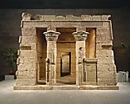

What is this?????
Challenge.

Are you an art aficionado????
Use your own subjective opinion to answer the following questions…

- Early Religious Paintings: What color is predominant in these pictures? What do you notice about the baby Jesus (hint: look closely at his face)? What do you see behind Mary’s head? Look at the backgrounds of the two Madonna and Child paintings. What’s in them? How did the backgrounds change in 200 years?
- Raphael: Look at Raphael’s baby Jesus. Does he look different from the pictures 200 years earlier? How about Mary? (Hint: Is she round or flat?)
- Picasso: Picasso started out as a classically trained artist. Then he discovered the modern / CUBIST movement. See how his style changed between the two pictures. Why do you think it’s called the cubist movement? Is the figure in the cubist painting a girl or boy? Do you know who it is? (hint: Think of the when in Rome movie….)
- Dali: Most well-known SURREALIST painter of our time. Why do you think it’s called surrealist? Remind me to show you the creepy poster I have in the attic.
- Degas: Preferred to be called a REALIST instead of an impressionist. He was at the end of the realist movement. Look at his pictures of the dancers and compare them to Monet’s figures. What do you think? Are his figures real or are they an impression? Why do you think the movement is called realist?
- Renoir: Leader in the IMPRESSIONIST movement. Why do you think it’s called impressionism? See how the paintings changed over time from Renoir to Monet. Do they get more or less impressionistic?
- Manet: Also a leader in the impressionist movement, transforming painting from the realist movement into impressionism. Degas, Monet, Manet, Pissarro, and Cezanne were all good friends. Compare the colors he uses in his pictures to what you see in real life.
- Monet: Stand close to a Monet painting. Now stand far away. How do the paintings change? Do the same with a Vermeer. How do they change?
- The Horse Fair: Duja’s favorite painting.
- The Storm: Duja’s other favorite painting. Be sure to tell her you saw them!
- Velazquez: Manet, Dali and Picasso all credit him for inspiring their style of painting. How do his paintings differ from Vermeer (for example)?
- Matisse: Leading figure in MODERN ART with his use of color.
- Lichtenstein: Prominent POP-ARTIST.
- Pollock: Leader in the ABSTRACT-IMPRESSIONIST movement.
- Gauguin: Leader in the POST-IMPRESSIONIST movement. Van Gogh cut off his ear for Gauguin. He painted in Arles! Imagine living in a world with no TV, planes or photos and seeing his paintings from the islands for the first time. Would you be scandalized?
- Rousseau: POST-IMPRESSIONIST period painter. Shunned at the time because he was self-taught, now he is considered a master.
- Van Gogh: Considered Post-Impressionist. Notice the cypress trees. Do they look familiar? He is very famous. Have you seen any of his paintings before.
- Cezanne: Another post-impressionist master.
- Rodin: My favorite sculptor. Ever. Compare the feeling of these two statues to the religious paintings we saw in the beginning.
- El Greco – not much to say.
- Rubens: Painted in the BAROQUE style. See how his paintings of women differ from Vermeer, done at the same time. They are called Rubenesque women. Now think about how the color and shape of his figures differ from Monet or Manet.
- Vermeer: Known for incredible detail and use of light. Where do you see the light in the picture? What do you see reflected on the surfaces of the items in the painting?

